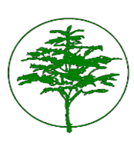

Northwood-Four Corners Civic Association (“NFCCA”) Holiday Social
December 10, 2025 – 6:30 pm
Forest Knolls Elementary School

A Holiday Social replaced the monthly NFCCA General Meeting on Wednesday, December 10, 2025, from 6:30 to 9:00 p.m.
There was a festive holiday market with local vendors set up at the school. New this year was a hot chocolate contest! There was a balloon artist and activities for kids, and carolers for the crowd. A slideshow with photos from this year’s community activities played in the background. Neighbors were invited to bring non-perishable food, which was collected and donated to Manna Food Center. Refreshments and treats were shared by all, and it was a cheerful event.
The next NFCCA general meeting will be held on February 11, 2026, at 7:30 pm.

Submitted by: Sarah Dye, Secretary

