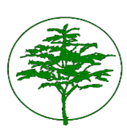

Northwood-Four Corners Civic Association (“NFCCA”) Holiday Event
December 13, 2023 – 7:30 pm
Forest Knolls Elementary School

A Winter Social replaced the monthly NFCCA General Meeting on Wednesday, December 13, 2023, from 7:30 to 9:00 p.m.
There was a festive holiday market with local vendors set up at the school. There were activities for kids, and carolers for the crowd. Neighbors were invited to bring non-perishable food, which was collected and donated to Manna Food Center. Refreshments and treats were shared by all, and it was a jolly event.
The next NFCCA general meeting will be held on February 7, 2024, at 7:30 pm.

Submitted by: Sarah Dye, Secretary

